***THEORY***

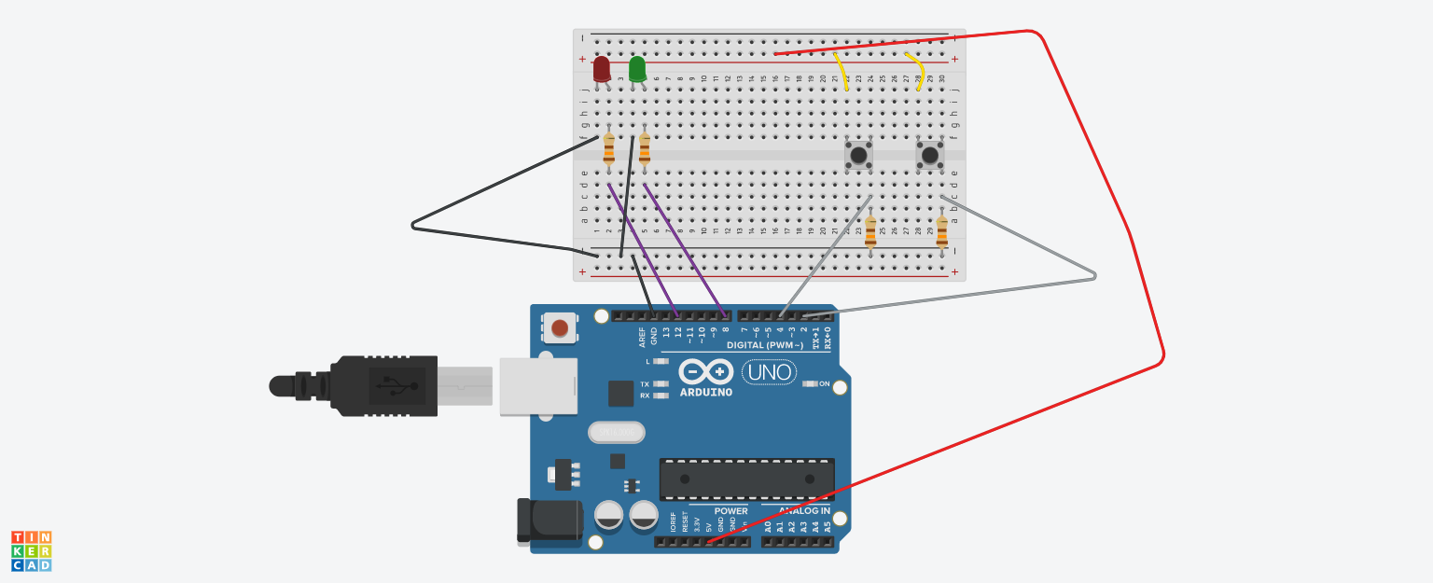

***CONCEPT USED:-***

The pushbutton is a component that connects two points in a circuit when you press it. The example turns on an LED when you press the button.

We connect three wires to the Arduino board. The first goes from one leg of the pushbutton through a pull-up resistor (here 2.2 KOhms) to the 5 volt supply. The second goes from the corresponding leg of the pushbutton to ground. The third connects to a digital i/o pin (here pin 7) which reads the button's state

***LEARNING AND OBSERVATIONS:-***

Following observations were recorded during experiment:

* The LED turns on when we click on the push button.
* When the pushbutton is open (unpressed) there is no connection between the two legs of the pushbutton, so the pin is connected to 5 volts (through the pull-up resistor) and we read a HIGH.
* When the button is closed (pressed), it makes a connection between its two legs, connecting the pin to ground, so that we read a LOW.

***PROBLEM AND TROUBLESHOOTING:-***

No problem was faced while making circuit and it went successfully.

***PRECAUTIONS:-***

The following precautions need to be considered while performing this experiment:

* The connections of the USB in both the PC and the ARDUINO UNO board should be snug.
* The USB ports of the PC and the ARDUINO UNO should be in working condition.
* The sketch should be logically and syntactically correct and germane to the experiment that needs to be performed.
* The correct serial port should be selected that is the one through which the ARDUINO UNO has been connected.
* Look for the errors during compilation and upload of the executable to the ARDUINO UNO.
* Disconnect the digital 1 and 0 pins while uploading the program to the board.
* Do not open more than one instance of the ARDUINO IDE at a time.

***LEARNING OUTCOMES:-***

The various learnings as the outcomes of performing the above-mentioned experiment are :

* Use of the digitalRead() function.
* Connecting push button to turn on/off an led.
* Connection of multiple LEDs to a single pin of the Arduino.